Alg 4 Name: ____________________________

______________ _____________

WS Assessment

Target 18:

Operation of Rational

Solving rational equation

**I can:**

* Multiply / Divide rational expression
* Add / Subtraction rational expression
* Solve rational equation

**Unit 5: Rational Expression and Their Operations**

* [**HSA.APR.D.6**](http://www.corestandards.org/Math/Content/HSA/APR/D/6/): Rewrite simple rational expressions in different forms; write *a*(*x*)/*b*(*x*) in the form *q*(*x*) + *r*(*x*)/*b*(*x*), where *a*(*x*), *b*(*x*), *q*(*x*), and *r*(*x*) are polynomials with the degree of *r*(*x*) less than the degree of *b*(*x*), using inspection, long division, or, for the more complicated examples, a computer algebra system.
* **H**[**SA.SSE.A.2**](http://www.corestandards.org/Math/Content/HSA/SSE/A/2/): Use the structure of an expression to identify ways to rewrite it. *For example, see x4 - y4 as (x2)2 - (y2)2, thus recognizing it as a difference of squares that can be factored as (x2 - y2)(x2 + y2)*.
* [**HSA.SSE.B.3.A**](http://www.corestandards.org/Math/Content/HSA/SSE/B/3/a/): Factor a quadratic expression to reveal the zeros of the function it defines.
* [**HSN.RN.B.3**](http://www.corestandards.org/Math/Content/HSN/RN/B/3/): Explain why the sum or product of two rational numbers is rational; that the sum of a rational number and an irrational number is irrational; and that the product of a nonzero rational number and an irrational number is irrational.

HW# 18 Rational Simplification www.deltamath.com

Multiply and simplify

$\frac{(x-3)}{(10x^{2}+6x)}∙\frac{(10x^{2}+6x)}{(x+8)}$ $\frac{(1)}{(x+6)}∙\frac{(6x^{2}+24x)}{(6x)}$

$\frac{(x-8)}{(x+9)}∙\frac{(x^{2}+4x-45)}{(x-5)}$ $\frac{(x+5)}{(x^{2}+12x+20)}∙\frac{(x^{2}+10x+16)}{(5-x)}$

$\frac{(5)}{(x+8)}∙\frac{(x^{2}+17x+72)}{(x+8)}$ $\frac{x^{4}-6x^{3}}{4x^{2}-20x+24}∙\frac{2x^{2}+6x-36)}{(x^{2}-36)}$

Divide and simplify

$\frac{1}{7-x}÷\frac{5x^{2}}{2x-14}$ $\frac{x^{2}-6x}{x^{2}-36}÷\frac{5}{x+6}$ $\frac{8x}{{6x}^{2}-18x}÷\frac{x-5}{x^{2}-8x+15}$

$\frac{(x^{2}+16x+63)}{(7x+49)}∙\frac{(7)}{(x^{2}+19x+90)}$ $\frac{x^{2}-7x-18}{{7x}^{3}-63x^{2}}÷\frac{x^{2}+3x+2}{7x^{3}+56x^{2}}$

Add / Subtracting and simplify

$\frac{2x}{x+2}+\frac{2x}{x-2}$ $\frac{2}{x-5}-\frac{4x}{x+3}$ $\frac{4}{3}+\frac{x-1}{x-2}$

Simplify Complex Rational

$$\frac{x-1}{\frac{1}{3}+\frac{9}{x-1}}$$

$$\frac{\frac{4}{x+4}-\frac{5}{4}}{\frac{x+4}{5}}$$

$$\frac{\frac{1}{x}+\frac{20}{3}}{\frac{3x}{5}-\frac{1}{5}}$$

$$\frac{\frac{2}{x-2}+\frac{1}{x+2}}{\frac{6}{x^{2}-4}}$$

Solve rational equation

$$\frac{x-6}{4x}=\frac{3}{2x}+1$$

$$\frac{x-7}{12}-\frac{x-1}{12x}=\frac{x+6}{6x}$$

$$\frac{x+5}{x^{2}-5x}-\frac{x-6}{2x^{2}-10x}=\frac{1}{2}$$

$$\frac{\frac{1}{x+1}-1}{1+\frac{1}{x+1}}=1$$

Simplify and graph both for stamp

$$f\left(x\right)=\frac{\frac{5}{x}-\frac{3}{x+3}}{\frac{2}{x^{2}+3x}+\frac{3}{x}}$$

Graph, write an equation, and give the asymptotes for each problem.

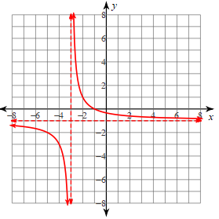

Asymptotes:

Domain:

Range:

Equation:

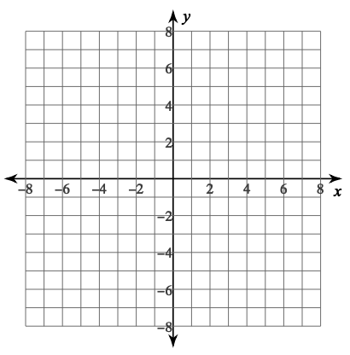

Asymptotes:

Domain:

Range:

Equation: $f\left(x\right)=-\frac{1}{x-1}-3$



Asymptotes:

Domain:

Range:

Equation: $f\left(x\right)=\frac{a}{x-b}+c$

Where a, b, c is your choice



Write the equation

**Assessment Target 18**

**I can…** perform operations on rational and solve rational function

$$\frac{5}{n-4}+\frac{5}{n+1}$$

$$\frac{3x}{x+4}+\frac{7x}{3x-1}$$

$$\frac{\frac{x}{36}-\frac{x+2}{9}}{\frac{1}{6}+\frac{1}{4}}$$

$$\frac{\frac{5x+10}{2}-\frac{x}{5}}{\frac{25}{x+2}+\frac{25}{x^{2}}}$$

Solve the for x

$$\frac{1}{x^{2}-4x-32}+\frac{1}{x-8}=\frac{8}{x^{2}-4x-32}$$

$$\frac{1}{2}-\frac{x}{x+4}=\frac{x-4}{4}$$

Simplify to the form f(x) = $\frac{a}{x-b}+c$ then graph, and give the asymptotes for f(x) = $\frac{1}{2}-\frac{x}{x+4}$ Stamp